Project Development Phase
Model Performance Test

Date | 08/10/2026
Team ID | SWTID-2026-3520
Project Name | Implement Client Script and UI Policy (Incident) – ServiceNow
Maximum Marks | 10 Marks

Model Performance Testing:
Project team shall fill the following information in model performance testing template.
S.No. | Parameter | Values | Screenshot
 | Metrics (Test Metrics) | Regression Model: Not applicable – this project is rule-based ServiceNow configuration (no ML model), so MAE, MSE, RMSE and R2 score are not used.  Equivalent test metrics (Expected results):  Test cases planned / executed – 12 / 12 (6 UI Policy, 6 Client Script).  Test cases passed / failed – 12 / 0.  Pass rate (accuracy score) – 100%.  Confusion matrix equivalent – conditions that should trigger a rule and did: 12; false triggers: 0; missed triggers: 0.  Classification Report equivalent – UI Policy rules, onLoad, onChange and onSubmit scripts each tested for the positive case and the negative case (condition not met, form returns to normal). | 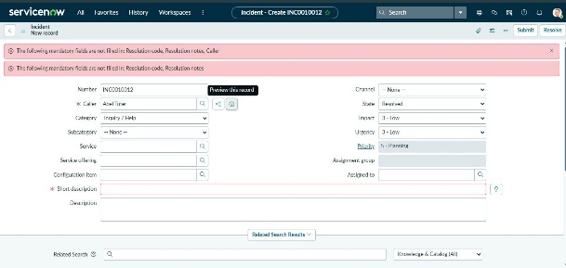  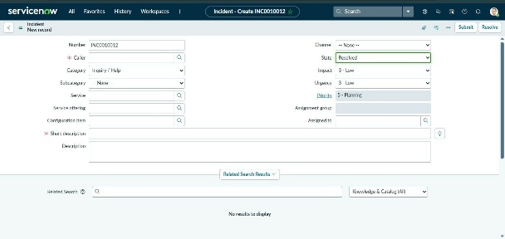
 | Tune the Model | Hyperparameter Tuning (configuration tuning) –  Set UI Policy order so conditions do not conflict; enabled "Reverse if false" and "Run scripts"; set the Short description minimum length to 10 characters; limited onChange scripts to the Category, Impact and Urgency fields to keep the form fast.  Validation Method –  Manual test cases in a developer instance (PDI); impersonation of agent and caller users; creating sample incidents for every State and Category; re-test after each change; changes then moved by update set. | 